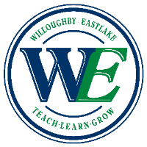
Summer Reading Assignment 2015
English I, II, III, IV Students, all levels
South High School

Think about this…
“The best books, they don’t talk about things you never thought about before. They talk about things you’d always thought about, but that you didn’t think anyone else had thought about. You read them, and suddenly you’re a bit less alone in the world. You’re part of this cosmic community of people who’ve thought this thing, whatever it happens to be. I think that’s what’s happened to you today. This fear, of squandering your future, was already on your mind. I just underlined it for you.”
-We All Looked Up by Tommy Wallach

Assignment for all levels of English I, II, III, and IV: READ! Pick a book this summer and read it! Be prepared to share your reaction to your chosen novel in the fall.

Assignment for all Honors and AP English classes: READ! Pick a book from The New York Times Best Seller List and be prepared to share your reaction to your chosen novel in the fall.

Good Luck and Happy Reading!

