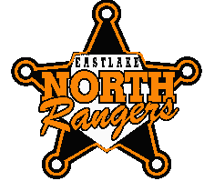
Eastlake North Boy’s Golf
1st ANNUAL

Fundraiser Outing

The Eastlake North Boy’s Golf Team is Proud to Host its
first ever fundraiser golf outing. Come out and have a great time while supporting the boy’s golf program.

Place: Lost Nation Golf Course, 38890 Hodgson Rd., Willoughby, Ohio 44094

Time: Saturday – May 31, 2014 (Shotgun Start 2:30 p.m.)

Format: Four Person Scramble (must be 18 or older to play)

What You Get:
- Prize for winning team
- 18 holes of golf on local municipal course
- Golf Cart per pair
- Entry in Door Prize Drawing, “Many Winners, Nice stuff!”
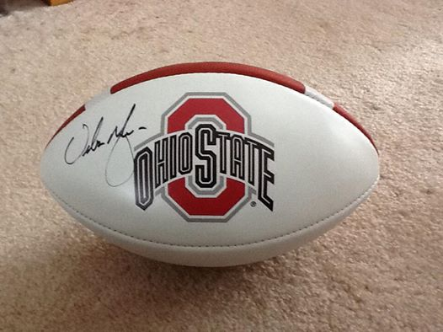
- Food at the turn(hot dog and a drink)
- Catered dinner
- Prize for: pin shot, longest drive

Options: (Additional Cost)
- Entry in skins game
- Entry in 50/50 raffle
- Mulligans
- Urban Meyer autographed football raffle

Cost: $75 per player / $300 per team of four
(Entry forms and payment required by 5/23/14)

Contact: For sign ups, more information, or to contact us, visit the Boys’ Golf webpage (under the “fall sports” tab) on the North High School Athletics Site. Call or e-mail with entry information and questions.
Matt Fundak (440) 975-3699, matthew.fundak@weschools.org
Matt Kozlevcar (440)975-3666, matt.kozlevcar@weschools.org

All proceeds will go to the North High Boy’s Golf team.
Friends and family welcome. See you on the links! Go Rangers!!!!

